CODE OF ADVERTISING
CONSULTATION QUESTIONNAIRE

June 2023

CODE OF ADVERTISING
CONSULTATION QUESTIONNAIRE

June 2023

1. Submission Instructions 3
2. Personal details form 4
3. Main Charaters in an Advertisment 5
4. Advertising within a Sponsored Program 8
5. Self-Protection Measures Message in Audiovisual and Audio Advertisements 11
6. Limitations on Sponsorships 14
7. Renaming Ban 17
8. Limitations on Promotions 18
9. Outdoor Signs 21
10. Outdoor advertisements on licensed premises 22

Submission Instructions

The purpose of this Consultation Questionnaire is to collect opinions, suggestions and proposals for the improvement of the current regulatory framework regarding betting advertising. These will be taken into account by the National Betting Authority when amending the existing Code of Advertising.

The Consultation Questionnaire must be submitted via email to the email address advertising@nba.gov.cy.

Submission deadline: July 7, 2023

Personal details form
Name and Surname:
[REPLY HERE]
Name of your organisation/company (if applicable):
[REPLY HERE]
Email address:
[REPLY HERE]
Professional capacity:
Member of the public,
Class A or B licensed bookmaker,
Authorised agent,
Person who works or has worked in a gambling business,
Academic (who does not represent an organization),
Academic institution,
Relevant trade body, association or organization,
NGO/charitable organization/non-profit organization,
Supervisory or other regulatory Authority in Cyprus.
As part of this consultation, we may publish your name, if you are responding in your personal capacity, or the name of your organization if you are responding on behalf of your organization, on our website for the purpose of marking your participation in it.
Do you consent to the publication of this information?
I CONSENT to the publication of my name or my organization.
I DO NOT CONSENT to the publication of my name or my organization.

Main Characters in an Advertisement

The existing regulation and in particular section 14(f) of the Code of Advertisement provides that, betting advertising on any media is prohibited if it includes a person who is or appears to be under the age of twenty-five (25) wagering or playing an important role in the advertisement.

The NBA’s intention is to to preserve the restriction of 14(f) of the Code and extend it to persons or characters whose example is likely to be followed by persons under the age of 18 or who have a strong appeal to persons under the age of 18.
Proposal 1
Proposed Regulation:
It is prohibited to advertise betting by any means if it includes a person or character whose example is likely to be followed by minors or which has a strong appeal to minors.

The NBA’s intention is to include an exhaustive list within the Practical Guide that determines, for the purposes of certainty, categories of persons and characters whose example is likely to be followed by minors.

For consultation purposes, the list includes the following persons:
- active players or athletes of any sport,
- presenters of shows or programs (audio-visual and audio),
- well-known personalities such as singers, participants in reality shows, actors, comedians, youtubers, influencers, etc.

Notwithstanding paragraph 3.3, licensees should exercise particular care in selecting individuals or characters to promote their services so that they do not have a strong appeal to minors. Licensees should consider whether the role, actions and activities associated with the particular person or character may influence or inspire persons under the age of 18. In addition, particular weight should be given to the profile and followers of that person, including the demographics of their followers on various social media. In the context of submitting relevant advertising plans, the NBA will expect a detailed analysis of the above in order to determine whether the regulation in question is violated or not.

The NBA is considering an exception to Proposal 1, where the persons mentioned in the indicative list of paragraph 3.3 or more generally, persons or characters who fall under the proposed regulation of paragraph 3.2 may participate/act in an advertisement of a licensee. This exemption will allow a betting advertisement to be disseminated only if the medium on which it will be broadcasted applies strict measures in order to verify the age of its audience, such as a Class B licensee's website or by email (verified player) or within Class A licensed premises.
Proposal 2
Proposed Amendment:
It is prohibited to advertise betting by any means, if it includes a person or character whose example is likely to be followed by minors or which has a strong appeal to minors, unless the medium of its transmission is such that it absolutely excludes its dissemination to minors

Consultation Questions
To what extent do you agree with Proposal 1, regarding the restriction of the main characters in a betting advertisement?
Strongly agree
Agree
Neither agree nor disagree
Disagree
Strongly disagree

Please give your reasons for your answer.
[REPLY HERE]
To what extent do you agree with the current regulation (Code 14(f))?
Strongly agree
Agree
Neither agree nor disagree
Disagree
Strongly disagree
Please give your reasons for your answer.
[REPLY HERE]
To what extend to you agree with the exception in Proposal 2?
Strongly agree
Agree
Neither agree nor disagree
Disagree
Strongly disagree
Please give your reasons for your answer.
[REPLY HERE]
Do you have any recommendations or proposals regarding any of the above?
[REPLY HERE]

Advertising within a Sponsored Program

The existing regulation and in particular section 33(5) of the Code of Advertisment provides that, “the permanent or periodic display of the bookmaker’s trade name on screen during the sponsored television programme, shall constitute advertising and shall be subject to all relevant limitations”. Moreover, code 33 provides that “oral announcements of sponsorships which are made by presenters or actors of the sponsored television or radio programme are prohibited” and that sponsorship announcements are allowed only “immediately before, during and immediately after broadcast of the sponsored television or radio programme”.

The vast majority of sponsored programs today circumvent the principles and restrictions of Part VI in such a way, that they are regarded primarily as advertisements. Consequently, these sponsored programs are obliged to display throughout their runtime all the data and information mentioned in Code 7 (the identity of the license holder, the fact that the services are licensed by the Authority, the fact that participation of minors in betting activity is forbidden and a reference to Safer Gambling).

The NBA’s intention is to prohibit advertising, product placement and the permanent or periodic display of the bookmaker’s trade name on screen during the sponsored programme.

With “Proposal 1”, the NBA proposes the absolute prohibition of advertising, product placement and the mentioning of the bookmaker or his products during a sponsored audio-visual or audio program.
Proposal 1
Proposed Regulation:
Prohibition of betting advertising or product placement during sponsored audiovisual or audio programming.

With “Proposal 2”, the NBA proposes on the one hand, the prohibition of advertising and product placement and, on the other hand, the announcement - subject to conditions - of sponsorship during the program.

Proposal 2
Proposed Regulation:
Prohibition of betting advertising or product placement during sponsored audiovisual or audio programming.
Proposed Amendment of 33(3):
Sponsorship announcements by presenters or actors of the sponsored television or radio audiovisual or audio program are prohibited permitted only once per hour and only if they include data and information described in Code 7:
Provided that, throughout the sponsorship announcement in an audiovisual program, the data and information of Code 7 are displayed on the screen as provided for in the Practical Guide.

Consultation Questions
To what extent do you agree with the ban on advertising within a sponsored program?
Strongly agree
Agree
Neither agree nor disagree
Disagree
Strongly disagree
Please give your reasons for your answer.
[REPLY HERE]
To what extent do you agree with the ban on product placement within a sponsored program?
Strongly agree
Agree
Neither agree nor disagree
Disagree
Strongly disagree
Please give your reasons for your answer.
[REPLY HERE]
To what extent do you agree with “Proposal 1”?
Strongly agree
Agree
Neither agree nor disagree
Disagree
Strongly disagree
To what extent do you agree with “Proposal” 2?
Strongly agree
Agree
Neither agree nor disagree
Disagree
Strongly disagree
Please give your reasons for your answer.
[REPLY HERE]
Do you have any recommendations or proposals regarding any of the above?
[REPLY HERE]

Self-Protection Measures Message in Audiovisual and Audio Advertisements

The existing regulation and in particular Code 16 of the Code of Advertising provides that, “audiovisual or audio betting advertising, regardless of the medium of transmission, is prohibited if there is no distinct concise reference to the existence of self-protection measures and safer gambling”. Furthermore, the Practical Guide states that the NBA considers the reference to be “distinct”, as far as audiovisual advertisements are concerned, if " it takes up at least 10% of the time duration of the advertisement and at least 25% of the height of the advertisement " and as regards the audio, if at the end of the advertisement it encourages “the listener to find out more about self-protection measures through the website www.safergambling.gov.cy”.

It is evident from the results of the "Quantitative Research on Sports Betting Advertising" (which was completed in May 2023) that the self-protection measures and Safer Gambling messaging is not being noticed by the viewers or listeners of the advertisements. Specifically, only 20% of the respondents reported noticing the message in question, while out of the non-player respondents only 13%.

The NBA’s intention is to significantly increase both the display time of the message and the space it occupies on the screen.
Proposed Amendment:
Extending the display time of messages in ads from 10% to 20%
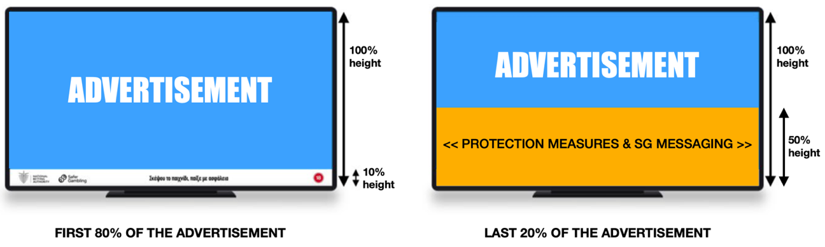
Expansion of the space it occupies on the screen from 25% of the height to 50%.

In regard to the message itself, the NBA is considering whether to continue with the current state of affairs, i.e. the message being designed and determined by the licensed bookmaker or whether the message and its design be determined by the NBA. Where the message will continue to be determined by the licensee, then the bookmaker will have to design different messages depending on the medium and the time/conditions on which the advertisement will be broadcasted in, for example a specific message during the half-time break of a sports match vs prior to the match.
Proposal 1
Proposed Amendment:
The messaging will be determined by the NBA.
Proposal 2
Proposed Amendment:
The messaging is determined by the licenced bookmaker and has to be appropriate to the conditions of the broadcasting medium.
Consultation Questions
To what extent do you agree with increasing display time of the messaging?
Strongly agree
Agree
Neither agree nor disagree
Disagree
Strongly disagree
To what extent do you agree with the increase in screen space?
Strongly agree
Agree
Neither agree nor disagree
Disagree
Strongly disagree

To what extent do you agree with the increase of both screen time and screen space?
Strongly agree
Agree
Neither agree nor disagree
Disagree
Strongly disagree
To what extent do you agree with “Proposal 1”?
Strongly agree
Agree
Neither agree nor disagree
Disagree
Strongly disagree
To what extent do you agree with “Proposal 2”?
Strongly agree
Agree
Neither agree nor disagree
Disagree
Strongly disagree
Please give your reasons for your answer.
[REPLY HERE]
Do you have any recommendations or proposals regarding any of the above?
[REPLY HERE]

Limitations on Sponsorships

The existing regulation and in particular Code 32 of the Code of Advertising provides that a licensed bookmaker may sponsor any program except news and current affairs programs, political information programs, children's programs, and church broadcasts.

The NBA’s intention is to determine an exhaustive list of programs/persons/purposes which a licensed bookmaker may sponsor.
Proposed Regulation:
A licensed bookmaker may only sponsor –
- sports news programs,
- individual sports athletes,
- sports associations or teams in the context of their participation in a sports event,
- broadcasts of sports matches,
- broadcasts/programs of sports content,
- conferences and training seminars,
- charitable and public benefit purposes.

The NBA is considering whether actions or sponsorships, carried out by licensees in the context of their social responsibility ("charitable and public benefit purposes"), should be performed under an alternative name or under the existing trade name written in full without branding, slogans or their logo, or a combination of these two options (alternative name together with existing trade name in full text without branding, slogans or their logo) for the purposes of protecting minors.
Proposal 1
Charitable and public benefit sponsorships are only permitted under an alternative name.
Proposal 2
Charitable and public benefit sponsorships are only allowed if the reference to the licensed bookmaker is written in full without branding, slogans or logo.
Proposal 3
Charitable and public benefit sponsorships are allowed only if they are under an alternative name along with a reference to the licensed bookmaker’s trade name written in full, without branding, slogans or logo.

Consultation Questions
To what extent do you agree with the proposed regulation?
Strongly agree
Agree
Neither agree nor disagree
Disagree
Strongly disagree
To what extent do you agree with the proposed list programs/persons/purposes which the licensed bookmaker may sponsor?
Strongly agree
Agree
Neither agree nor disagree
Disagree
Strongly disagree
Please give your reasons for your answer.
[REPLY HERE]
Do you have any recommendations or proposals regarding any of the above?
[REPLY HERE]
To what extent do you agree with “Proposal 1”?
Strongly agree
Agree
Neither agree nor disagree
Disagree
Strongly disagree
To what extent do you agree with “Proposal 2”?
Strongly agree
Agree
Neither agree nor disagree
Disagree
Strongly disagree
To what extent do you agree with “Proposal 3”?
Strongly agree
Agree
Neither agree nor disagree
Disagree
Strongly disagree
Please give your reasons for your answer.
[REPLY HERE]
Do you have any recommendations or proposals regarding any of the above?
[REPLY HERE]

Renaming ban in the context of sponsorships
Proposed Regulation:
The sponsorship of any organization, foundation, club or sports venue is prohibited, if it is attained in the form of renaming to include the name, a phrase, initials or any other form of reference to the licensee’s tradename.

Consultation Questions
To what extent do you agree with the proposed prohibition?
Strongly agree
Agree
Neither agree nor disagree
Disagree
Strongly disagree
Please give your reasons for your answer.
[REPLY HERE]
Do you have any recommendations or proposals regarding any of the above?
[REPLY HERE]

Limitations on Promotions
Proposed Regulation 1:
Maximum amount that can be offered as part of the promotion
(For example €100)
Proposed Regulation 2:
Limitations on the frequency of offering deposit bonuses
(For example only 1-2 times a month)
Proposed Regulation 3:
Setting conditions for the offering bonuses
(For example only if a month has passed since player registration or only the player’s identity has been verified)
Proposed Regulation 4:
Ban the offering bonuses to players considered by the licensed bookmaker to be high-risk players according to regulation 15 of the Player Protection Regulations

Consultation Questions
To what extent do you agree with Proposed Regulation 1?
Strongly agree
Agree
Neither agree nor disagree
Disagree
Strongly disagree
Do you have any suggestions regarding Proposed Regulation 1?
[REPLY HERE]
To what extent do you agree with Proposed Regulation 2?
Strongly agree
Agree
Neither agree nor disagree
Disagree
Strongly disagree
Do you have any suggestions regarding Proposed Regulation 2?
[REPLY HERE]
To what extent do you agree with Proposed Regulation 3?
Strongly agree
Agree
Neither agree nor disagree
Disagree
Strongly disagree
Do you have any suggestions regarding Proposed Regulation 3?
[REPLY HERE]
To what extent do you agree with Proposed Regulation 4?
Strongly agree
Agree
Neither agree nor disagree
Disagree
Strongly disagree
Do you have any suggestions regarding Proposed Regulation 4?
[REPLY HERE]

Outdoor Signs

The NBA’s intention is to significantly reduce betting advertisements on outdoor signs (billboards) both within urban areas and within villages, without excluding their absolute prohibition within these areas.

According to the results of the "Quantitative Research on the Advertising of Sports Betting", which was completed in May 2023, 40% of the respondents are aligned with the NBA’s intention on the matter, as they agree with banning all betting advertisements on billboards in cities and villages.

Consultation Questions
To what extent do you agree with the NBA’s intention to reduce betting advertisements through billboards in these areas?
Strongly agree
Agree
Neither agree nor disagree
Disagree
Strongly disagree
Do you have any suggestions in regard to this?
[REPLY HERE]
To what extent do you agree with the NBA’s intention to ban betting advertisements through billboards in these areas?
Strongly agree
Agree
Neither agree nor disagree
Disagree
Strongly disagree
Do you have any suggestions in regards to this?
[REPLY HERE]

Outdoor advertisements on licensed premises

The NBA’s intention is to prohibit all betting advertisements on licensed premises which target the exterior or surrounding area of the premises, such as poster-advertisements in the shop’s windows. It should be noted that such an amendment will not affect or limit the ability of the premise license holder to post announcements related to the operation of the store.
Proposed Regulation 1:
It is prohibited to advertise betting from licensed premises if the advertisement mainly or exclusively targets the exterior or surrounding area of the premises.

Furthermore, the NBA’s intention is to limit both the number of times the logo/trade name of the Class A bookmaker appears, as well as the maximum area that it occupies on the facade of the licensed premises. The NBA’s suggestion is that the bookmaker’s logo/trade name appears only once per face of the store and that its maximum surface be proportional to the available length per face, probably with a specified minimum allowable surface, for cases where the length of the face is limited.
Proposed Regulation 2:
The Class A bookmaker’s logo or trade name shall be placed only once per face of the licensed premises and shall not exceed X% of the length of each face of the premises.
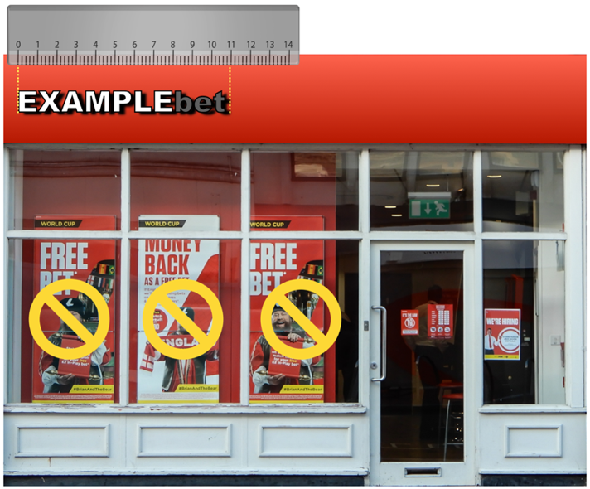

Example:
Combination of Proposal 1+2

Consultation Questions
To what extent do you agree with Proposed Regulation 1?
Strongly agree
Agree
Neither agree nor disagree
Disagree
Strongly disagree
Do you have any suggestions regarding Proposed Regulation 1?
[REPLY HERE]
To what extent do you agree with Proposed Regulation 2?
Strongly agree
Agree
Neither agree nor disagree
Disagree
Strongly disagree
What would be your preferred percentage in regards to Proposed Regulation 2 and what should be your preferred minimum allowed surface?
[REPLY HERE]
Do you have any suggestions regarding Proposed Regulation 2?
[REPLY HERE]

